

Enhancing Recognition of High Quality, Functional IFSP Outcomes
A training activity for infant and toddler service providers

June 2014 (updated August 2024)

Anne Lucas, Kathi Gillaspy, Mary Louise Peters and Joicey Hurth
with support from Dathan Rush, M’Lisa Shelden, Debbie Cate, and Megan Vinh

Please cite as:
Lucas, A., Gillaspy, K., Peters, M. L., & Hurth, J. (2014). Enhancing recognition of high quality, functional IFSP outcomes. Retrieved from https://ectacenter.org/~docs/topics/ifsp/rating-ifsp.docx

This resource was originally produced and distributed by the National Early Childhood Technical Assistance Center, funded through cooperative agreement number H326P120002 from the Office of Special Education Programs. The ECTA Center is a program of the FPG Child Development Institute of the University of North Carolina at Chapel Hill, funded through cooperative agreement number H326P220002 from the Office of Special Education Programs, U.S. Department of Education. Opinions expressed herein do not necessarily represent the Department of Education's position or policy.
Project Officer: Julia Martin Eile

Enhancing Recognition of High Quality, Functional IFSP Outcomes
A training activity for infant and toddler service providers

Table of Contents

Activity Preparation
Enhancing Recognition of High Quality, Functional IFSP Outcomes 2
Table of Contents 2
Enhancing Recognition of High Quality, Functional IFSP Outcomes 3
Rating IFSP Outcomes Using Placemats and Cards 3
Debriefing the Activity with Participants 5
Rating IFSP Outcomes Using Worksheets 5
Rating IFSP Outcomes Using Minimal Materials 5

Activity Materials
Criteria Defining High Quality, Participation-Based IFSP Outcomes 6
Sample IFSP Outcome Statements 7
Placemat for Rating IFSP Outcome Statements 19
Answer Key for Rating IFSP Outcome Statements 20
Worksheet for Rating IFSP Outcome Statements 22
References 24

Enhancing Recognition of High Quality, Functional IFSP Outcomes
A training activity for infant and toddler service providers
Recommended for groups of 3–6 people each
This training activity supports participants’ understanding of criteria needed to develop and write high quality, participation-based Individualized Family Service Plan (IFSP) outcomes. The term “functional” is used to describe what outcomes ought to be, but many providers struggle to define what makes an outcome “functional”. Others struggle with making outcomes meet the criteria set forth in regulations, as well as have meaning for families. Reviews of existing resources developed by national experts provided a framework for considering IFSP outcomes to determine if the outcomes are high quality and support the child’s participation in everyday routines and activities.
Supporting the development of high quality, participation-based outcomes requires a clear and deliberate link between every step of the IFSP process, beginning with interactions with the family during initial contacts and referral, through the development of the IFSP, and beyond. The fundamental belief that children learn best through their participation in everyday activities and routines with familiar people is critical. To accomplish this, providers should develop three important skills:
- the ability to understand how to gather information from families throughout the process,
- the ability to conduct a functional assessment that gives a clear picture of the child’s abilities and needs in the child’s natural, everyday settings, activities and routines, and;
- the ability to use the information to develop outcomes.
Throughout the process of gathering information from families, special attention should be paid to the information the family shares about what’s working well for them, as well as what is challenging. When paired with the provider’s knowledge of early development and functional assessment occurring in multiple situations and settings and over time, information from families provides all that is needed to develop high quality, participation-based outcomes.
In this activity, participants learn what the criteria for a high-quality, participation based IFSP outcome are, and apply that knowledge to sample IFSP statements to determine if they are high quality (meets all criteria) or substandard (does not meet all criteria). It’s fine if activity participants have varying levels of experience with the IFSP, but be sure to distribute those will less experience into groups that also include those with more experience.
Download IEP Goal Version: https://ectacenter.org/~pdfs/pubs/rating-iep.pdf

Rating IFSP Outcomes Using Placemats and Cards

Prepare Materials
- Print the Criteria (page 6) for each participant, at least one Answer Key (pages 20–21) for each facilitator or group.
- Print one set of 22 Sample IFSP Outcome Statements (page 8–18) for each group. Trim the cards down 4x6” using the cutting guide lines. For a more durable set, you can print them on card stock, or glue the printed paper to a 4 x 6” card.
- Print a Placemat (page 19) for each set of cards.
- If the activity will be performed with IEP groups, print the placemat on either side of the same page. Placemats can be laminated for durability.

Activity Instructions
- Provide a copy of the Criteria to each participant.
- Give one Placemat and one set of 22 Sample IFSP Outcome Statement cards to each group. Have each group place a card in the center of the placemat so that the printed grid on the card lines up with the placemat.
- Have the groups discuss and rate each statement according to the criteria recording a “yes” or “no” in the space provided in the card’s border. Remind the participants that additional criteria should be considered when a child’s IFSP and assessment information is available.
- After rating each statement, have the group determine if it is high quality (meets all criteria) or substandard (did not meet all criteria).
- Distribute the Answer Key and have participants to compare it to their own answers.

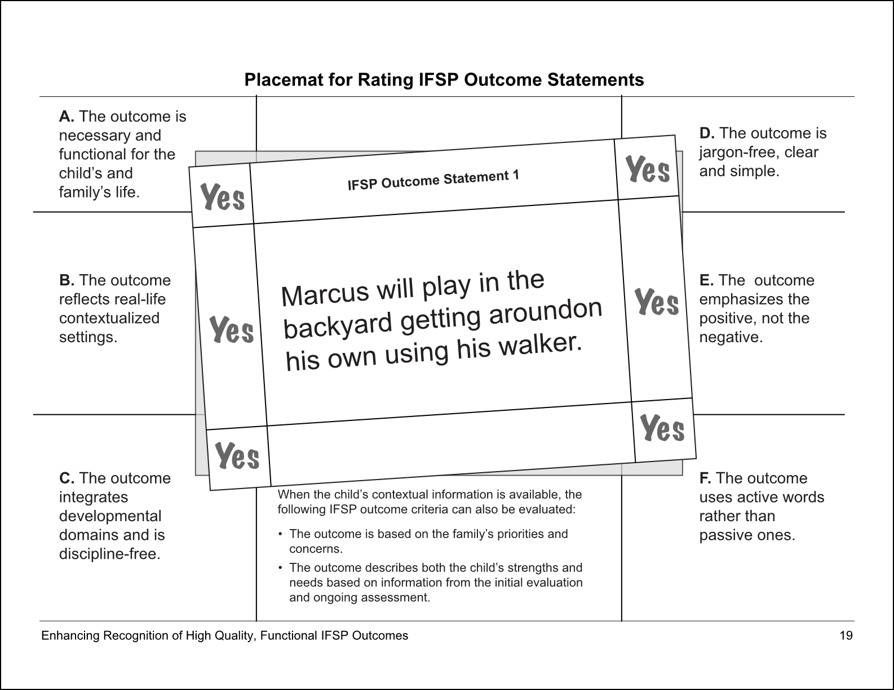
Optional 11x17” Placemat: https://ectacenter.org/~pdfs/pubs/rating-ifsp-placemat-11x17.pdf

Debriefing the Activity with Participants
After completing the activity, prompt participants with questions, for example:
- Where did you get stuck with an outcome statement?
- What sorts of varying interpretations of the criteria did you find?
- How might this activity help you in your work and within your team?
- What additional supports do you need to help you successfully identify if an IFSP Outcome is of high quality and is participation-based?
Those using the activity to fit the context of the participants and their learning needs might add other questions to the debriefing.

Rating IFSP Outcomes Using Worksheets
This version of the activity is ideal for groups where each participant rates the outcomes on their own.
- Provide copies of the Criteria (page 6) and the Worksheet (pages 22–23) to participants.
- Randomize the order in which participants will rate the Sample IFSP Outcome Statements.
- Have participants rate each outcome using the criteria, recording a “Yes” or a “No”. Remind the participants that additional criteria should be considered when a child’s IFSP and assessment information is available.
- Have the groups discuss and determine if the statement is high quality (meets all criteria) or substandard (did not meet all criteria).
- Participants can then compare their answers with the Answer Key (pages 20–21).

Rating IFSP Outcomes Using Minimal Materials
This simple and environmentally friendly version of the is ideal for small groups. To reduce the amount of notetaking needed, review the Answer Key (pages 20–21) after each outcome.
- Print a copy of the Criteria and Sample IFSP Outcome Statements (pages 6–7) for each participant.
- Randomize the order in which participants will rate the statements.
- Have the group discuss and rate each statement according to the criteria, determining if it is high quality (meets all criteria) or substandard (did not meet all criteria). Remind the participants that additional criteria should be considered when a child’s IFSP and assessment information is available.

Criteria Defining High Quality, Participation-Based IFSP Outcomes

A. The outcome is necessary and functional for the child’s life and the family’s life.
The outcome focuses on supporting the child and family’s participation in community life and family activities that are important to them.
The outcome benefits the child’s building social relationships, acquiring and using knowledge and skills, or taking using appropriate actions to meet needs.
The outcome helps the child or family improve participation in chosen activities, or begin new activities that important to them.
What is necessary and functional is not determined by what the practitioner thinks is meaningful and functional for the family.

B. The outcome reflects real-life contextualized settings.
The outcome reflects the everyday activity settings and routines for the child and family, for example, mealtime, bathing, and riding in the car—any other routine or other activity specific to the family.
Specific isolated skills (for example, test items that were missed during an evaluation) are not real-life or contextualized.

C. The outcome integrates developmental domains and is discipline-free.
The outcome describes the child’s participation in routines and everyday activity settings, and promotes skill development across multiple domains that can be addressed by the IFSP team.
The outcome makes the child or family the actors—the people doing something—not an occupational therapist or early interventionist.
Example: “The physical therapist will work with Ana to improve her balance” does not meet this criterion. “Ana will pull to a standing position and maintain her balance” does.

D. The outcome is jargon-free, clear, and simple.
The outcome is understandable by the family, uses plain language, and does not include professional jargon or “practitioner-speak”.
Example: The outcome describes how the child will move, such as reaching up or down for toys, not “range of motion”.
Example: The outcome describes a child speaking words clearly or making themselves understood, not their “articulation”.

E. The outcome emphasizes the positive, not the negative.
The outcome statement is phrased in the positive. It states what child or family will do, as opposed to what they will not do or what they will stop doing.
If there are any negative words within the statement, it is not a positively worded outcome.
Example: “Johnny will not spit out food when eating with his family” does not meet this criterion, but “Johnny will chew and swallow food when eating with his family” does.

F. The outcome uses active words, not passive words.
The outcome encourages the child or family’s active participation or engagement. Active words include eat, play, talk, walk, and so on. These words indicate what the child or family will do.
Passive words reflect a state of being, for example, tolerate and receive. Passive words also reflect a change or lack of change in performance (for example, increase, decrease, improve, and maintain).

Sample IFSP Outcome Statements

- Marcus will play in the backyard getting around on his own using his walker.
- Dahlia will join the family on short hikes at Upper Creek Falls and ride comfortably in her infant carrier.
- Robin will stop having tantrums at separation from primary caregiver when going to day care.
- Lily will go fishing with her family and hold her own fishing pole.
- Davis will talk more and pronounce words better.
- Thomas will put up with lying on his stomach for 10 minutes without crying.
- I want my child to walk.
- Lanesha will gradually stop eating baby food and eat more solid foods.
- Miles will be happy and relaxed when his mom leaves him at child care.
- Angel will participate in reciprocal turn taking during one-to-one facilitation.
- Romeo will go visit grandma and ride in his car seat all the way to her house.
- Enzo will stack 4 blocks.
- Bonnie will use a pincer grasp to flip a switch.
- Phu will eat enough food so he can gain weight and not have to have surgery.
- Walker will greet friends at story time at the library.
- Marta will participate in range of motion and strengthening exercises.
- Leroy will play together with his brother while his mom is making meals and express himself using gestures and words.
- Kimmie will play with her toys so Grandma can cook breakfast and get the older kids off to school.
- Miguel will improve his sleeping patterns 4 out of 5 times.
- The occupational therapist will assist Jana in grasping objects.
- Kamika will sleep through the night.
- Ahmet will get to eat what he wants during mealtimes by pointing or looking at choices his parents provide.

Criteria Defining High Quality, Participation-Based IFSP Outcomes
Rate each statement using the criteria to determine if it is high quality (meets all criteria) or substandard (did not meet all criteria).
- The outcome is necessary and functional for the child’s and family’s life.
- The outcome reflects real-life contextualized settings.
- The outcome integrates developmental domains and is discipline-free.
- The outcome is jargon-free, clear, and simple.
- The outcome emphasizes the positive, not the negative.
- The outcome uses active words, not passive words.
When the child’s contextual information is available (for example, assessment information, the child’s IFSP), the following IFSP outcome criteria should also be evaluated:
- The outcome is based on the family’s priorities and concerns, and
- The outcome describes both the child’s strengths and needs based on the information from the initial evaluation and ongoing assessment.

Sample outcome statements provided by Dathan Rush and M’Lisa Shelden of the Family, Infant and Preschool Program, Morganton, NC

IFSP Outcome Statement 1

Marcus will play in the backyard getting around on his own using his walker.

IFSP Outcome 2

Dahlia will join the family on short hikes at Upper Creek Falls and ride comfortably in her infant carrier.

IFSP Outcome Statement 3

Robin will stop having tantrums at separation from primary caregiver when going to day care.

IFSP Outcome Statement 4

Lily will go fishing with her family and hold her own fishing pole.

IFSP Outcome Statement 5

Davis will talk more and pronounce words better.

IFSP Outcome Statement 6

Thomas will put up with lying on his stomach for 10 minutes without crying.

IFSP Outcome Statement 7

I want my child to walk.

IFSP Outcome Statement 8

Lanesha will gradually stop eating baby food and eat more solid foods.

IFSP Outcome Statement 9

Miles will be happy and relaxed when his mom leaves him at child care.

IFSP Outcome Statement 10

Angel will participate in reciprocal turn taking during one-to-one facilitation.

IFSP Outcome Statement 11

Romeo will go visit grandma and ride in his car seat all the way to her house.

IFSP Outcome Statement 12

Enzo will stack four blocks.

IFSP Outcome Statement 13

Bonnie will use a pincer grasp to flip a switch.

IFSP Outcome Statement 14

Phu will eat enough food so he can gain weight and not have to have surgery.

IFSP Outcome Statement 15

Walker will greet friends at story time at the library.

IFSP Outcome Statement 16

Marta will participate in range of motion and strengthening exercises.

IFSP Outcome Statement 17
Leroy will play together with his brother while his mom is making meals and express himself using gestures and words.

IFSP Outcome Statement 18

Kimmie will play with her toys so Grandma can cook breakfast and get the older kids off to school.

IFSP Outcome Statement 19

Miguel will improve his sleeping patterns 4 out of 5 times.

IFSP Outcome Statement 20

The occupational therapist will assist Jana in grasping objects.

IFSP Outcome Statement 21

Kamika will sleep through the night.

IFSP Outcome Statement 22

Ahmet will get to eat what he wants during mealtimes by pointing or looking at choices his parents provide.

Placemat for Rating IFSP Outcome Statements
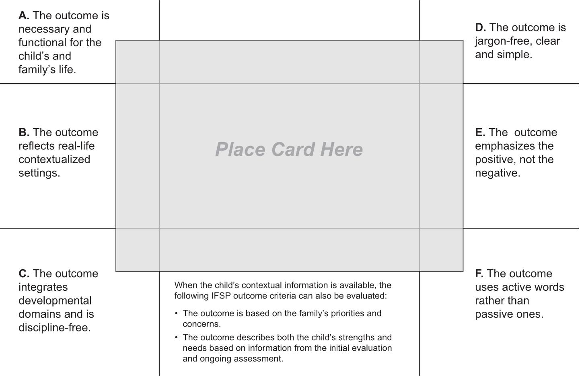

Answer Key for Rating IFSP Outcome Statements
A high quality statement meets all criteria. A substandard statement does not meet all criteria.
Sample IFSP Outcome Statement | A.  Necessary and functional | B.  Real-life contextualized settings | C.  Integrates domains, discipline-free | D.  Jargon-free, clear, simple | E.  Positive, not negative | F.  Active, not passive
- Marcus will play in the backyard getting around on his own using his walker. | Yes | Yes | Yes | Yes | Yes | Yes
- Dahlia will join the family on short hikes at Upper Creek Falls and ride comfortably in her infant carrier. | Yes | Yes | Yes | Yes | Yes | Yes
- Robin will stop having tantrums at separation from primary caregiver when going to day care. | Yes | Yes | Yes | No | No | Yes
- Lily will go fishing with her family and hold her own fishing pole. | Yes | Yes | Yes | Yes | Yes | Yes
- Davis will talk more and pronounce words better. | Yes | No | No | Yes | Yes | Yes
- Thomas will put up with lying on his stomach for 10 minutes without crying. | No | No | Yes | Yes | No | No
- I want my child to walk. | Yes | No | No | Yes | Yes | No
- Lanesha will gradually stop eating baby food and eat more solid foods. | Yes | No | Yes | Yes | No | Yes
- Miles will be happy and relaxed when his mom leaves him at child care. | Yes | Yes | Yes | Yes | Yes | Yes
- Angel will participate in reciprocal turn taking during one-to-one facilitation. | No | No | Yes | Yes | Yes | Yes
- Romeo will go visit grandma and ride in his car seat all the way to her house. | Yes | Yes | Yes | Yes | Yes | Yes
- Enzo will stack 4 blocks. | No | No | Yes | Yes | Yes | Yes
- Bonnie will use a pincer grasp to flip a switch. | No | No | No | No | Yes | Yes
- Phu will eat enough food so he can gain weight and not have to have surgery. | Yes | Yes | Yes | Yes | Yes | Yes
- Walker will greet friends at story time at the library. | Yes | Yes | Yes | Yes | Yes | Yes
- Marta will participate in range of motion and strengthening exercises. | No | No | No | No | Yes | No
- Leroy will play together with his brother while his mom is making meals and express himself using gestures and words. | Yes | Yes | Yes | Yes | Yes | Yes
- Kimmie will play with her toys so Grandma can cook breakfast and get the older kids off to school. | Yes | Yes | Yes | Yes | Yes | Yes
- Miguel will improve his sleeping patterns 4 out of 5 times. | Yes | No | Yes | No | Yes | No
- The occupational therapist will assist Jana in grasping objects. | No | No | No | No | Yes | No
- Kamika will sleep through the night. | Yes | Yes | Yes | Yes | Yes | Yes
- Ahmet will get to eat what he wants during mealtimes by pointing or looking at choices his parents provide. | Yes | Yes | Yes | Yes | Yes | Yes

Worksheet for Rating IFSP Outcome Statements
Rate each statement using the criteria to determine if it is high quality (meets all criteria) or substandard (did not meet all criteria).
Sample IFSP Outcome Statement | A.  Necessary and functional | B.  Real-life contextualized settings | C.  Integrates domains, discipline-free | D.  Jargon-free, clear, simple | E.  Positive, not negative | F.  Active, not passive
- Marcus will play in the backyard getting around on his own using his walker.
- Dahlia will join the family on short hikes at Upper Creek Falls and ride comfortably in her infant carrier.
- Robin will stop having tantrums at separation from primary caregiver when going to day care.
- Lily will go fishing with her family and hold her own fishing pole.
- Davis will talk more and pronounce words better.
- Thomas will put up with lying on his stomach for 10 minutes without crying.
- I want my child to walk.
- Lanesha will gradually stop eating baby food and eat more solid foods.
- Miles will be happy and relaxed when his mom leaves him at child care.
- Angel will participate in reciprocal turn taking during one-to-one facilitation.
- Romeo will go visit grandma and ride in his car seat all the way to her house.
- Enzo will stack 4 blocks.
- Bonnie will use a pincer grasp to flip a switch.
- Phu will eat enough food so he can gain weight and not have to have surgery.
- Walker will greet friends at story time at the library.
- Marta will participate in range of motion and strengthening exercises.
- Leroy will play together with his brother while his mom is making meals and express himself using gestures and words.
- Kimmie will play with her toys so Grandma can cook breakfast and get the older kids off to school.
- Miguel will improve his sleeping patterns 4 out of 5 times.
- The occupational therapist will assist Jana in grasping objects.
- Kamika will sleep through the night.
- Ahmet will get to eat what he wants during mealtimes by pointing or looking at choices his parents provide.

References

- McWilliam, R. A. (2006). Steps to build a functional outcome. Siskin Children’s Institute.
- McWilliam, R. A. (2009). Goal Functionality Scale III. Retrieved from https://ectacenter.org/~pdfs/topics/families/GoalFunctionalityScaleIII_2_.pdf
- Rush, M. L., & Shelden, D. D. (2009). Tips and techniques for developing participation-based IFSP outcomes statements, BriefCASE, 2(1). Retrieved from https://fipp.ncdhhs.gov/wp-content/uploads/briefcase_vol2_no1.pdf
- U.S. Department of Education, Office of Special Education and Rehabilitative Services. (2000). A guide to the Individualized Education Program. Retrieved from https://www2.ed.gov/parents/needs/speced/iepguide/iepguide.pdf
- U.S. Department of Education, Office of Special Education and Rehabilitative Services. (n.d.). Model form: Individualized Education Plan. Retrieved from https://www2.ed.gov/policy/speced/guid/idea/modelform-iep.pdf
- Bar-Lev, N., Van Haren, B., Laffin, K., Wright, A., Derginer, M., Graves, T., Kubinski, E., & Bernt,. S. (2009). A guide to connecting academic standards and IEPs (draft).
- OSEP TA Community of Practice, Workgroup on Principles and Practices in Natural Environments. (2008). Mission and key principles of early intervention services. Retrieved from https://ectacenter.org/topics/eiservices/keyprinckeyprac.asp
- OSEP TA Community of Practice, Workgroup on Principles and Practices in Natural Environments. (2008). Seven key principles: Looks like/doesn't look like. Retrieved from https://ectacenter.org/topics/eiservices/keyprinckeyprac.asp
- OSEP TA Community of Practice, Workgroup on Principles and Practices in Natural Environments. (2008). Agreed upon practices for providing early intervention services in natural environments. Retrieved from https://ectacenter.org/topics/eiservices/keyprinckeyprac.asp
- Early Childhood Technical Assistance Center. (2024). IFSP/IEP-Outcomes Integration. Retrieved from https://ectacenter.org/eco/pages/ifsp-iep.asp
- Early Childhood Outcomes Center, IFSP/IEP-Outcomes Integration Think Tank. (2010). Integrating child outcome measurement with the Individualized Education Program (IEP) process: Implementation Rating Scale.

