

Enhancing Recognition of High Quality, Functional IEP Goals
A training activity for early childhood special education staff

June 2014 (updated August 2024)

Anne Lucas, Kathi Gillaspy, Mary Louise Peters and Joicey Hurth
with support from Dathan Rush, M’Lisa Shelden, Debbie Cate, and Megan Vinh

Please cite as:
Lucas, A., Gillaspy, K., Peters, M. L., & Hurth, J. (2014). Enhancing recognition of high quality, functional IEP goals. Retrieved from https://ectacenter.org/~docs/topics/iep/rating-iep.docx

This resource was originally produced and distributed by the National Early Childhood Technical Assistance Center, funded through cooperative agreement number H326P120002 from the Office of Special Education Programs. The ECTA Center is a program of the FPG Child Development Institute of the University of North Carolina at Chapel Hill, funded through cooperative agreement number H326P220002 from the Office of Special Education Programs, U.S. Department of Education. Opinions expressed herein do not necessarily represent the Department of Education's position or policy.
Project Officer: Julia Martin Eile

Enhancing Recognition of High Quality, Functional IEP Goals
A training activity early childhood special education staff

Table of Contents

Activity Preparation
Enhancing Recognition of High Quality, Functional IEP Goals 2
Table of Contents 2
Enhancing Recognition of High Quality, Functional IEP Goals 3
Rating IEP Goals Using Placemats and Cards 3
Debriefing the Activity with Participants 5
Rating IEP Goals Using Worksheets 5
Rating IEP Goals Using Minimal Materials 5

Activity Materials
Criteria Defining High Quality, Participation-Based IEP Goals 6
Sample IEP Goal Statements 7
Placemat for Rating IEP Goal Statements 20
Answer Key for Rating IEP Goal 21
Worksheet for Rating IEP Goal Statements 24
References 27

Enhancing Recognition of High Quality, Functional IEP Goals
A training activity for early childhood special education staff
Recommended for groups of 3–6 people each
This training activity supports participants’ understanding of the criteria needed to develop and write high quality, participation-based Individualized Education Program (IEP) goals. The term “functional” is used to describe what outcomes ought to be, but many providers struggle to define what makes an outcome “functional”. Others struggle with making outcomes meet the criteria set forth in regulations, as well as have meaning for families. Reviews of existing resources developed by national experts provided a framework for considering IEP goals to determine if the outcomes are high quality and support the child’s participation in everyday routines and activities.
Supporting the development of high quality, participation-based outcomes requires a clear and deliberate link between every step of the IFSP process, beginning with interactions with the family during initial contacts and referral, through the development of the IFSP, and beyond. The fundamental belief that children learn best through their participation in everyday activities and routines with familiar people is critical. To accomplish this, providers should develop three important skills:
- the ability to understand how to gather information from families throughout the process,
- the ability to conduct a functional assessment that gives a clear picture of the child’s abilities and needs in the child’s natural, everyday settings, activities and routines, and;
- the ability to use the information to develop outcomes.
Throughout the process of gathering information from families, special attention should be paid to the information the family shares about what’s working well for them, as well as what is challenging. When paired with the ECSE staff's knowledge of early development and functional assessment occurring in multiple situations and settings, and over time, information from families provides all that is needed to develop high quality, participation-based goals.
In this activity, participants learn what the criteria for a high-quality, participation based IEP goals are, and apply that knowledge to sample IEP goals to determine if they are high quality (meets all criteria) or substandard (does not meet all criteria). It’s fine if activity participants have varying levels of experience with the IEP, but be sure to distribute those will less experience into groups that also include those with more experience.
Download IFSP Outcomes Version: http://ectacenter.org/~pdfs/pubs/rating-ifsp.pdf

Rating IEP Goals Using Placemats and Cards

Prepare Materials
- Print the Criteria (page 6) for each participant, at least one Answer Key (pages 21–23) for each facilitator or group.
- Print one set of 22 Sample IEP Goals (page 8–19) for each group. Trim the cards down 4x6” using the cutting guide lines. For a more durable set, you can print them on card stock, or glue the printed paper to a 4 x 6” card.
- Print a Placemat (page 20) for each set of cards.
- If the activity will be performed with IEP groups, print the placemat on either side of the same page. Placemats can be laminated for durability.

Activity Instructions
- Provide a copy of the Criteria to each participant.
- Give one Placemat and one set of 24 Sample IEP Goal cards to each group. Have each group place a card in the center of the placemat so that the printed grid on the card lines up with the placemat.
- Have the groups discuss and rate each statement according to the criteria recording a “yes” or “no” in the space provided in the card’s border. Remind the participants that additional criteria should be considered when a child’s IEP and assessment information is available.
- After rating each statement, have the group determine if it is high quality (meets all criteria) or substandard (did not meet all criteria).
- Distribute the Answer Key and have participants to compare it to their own answers.

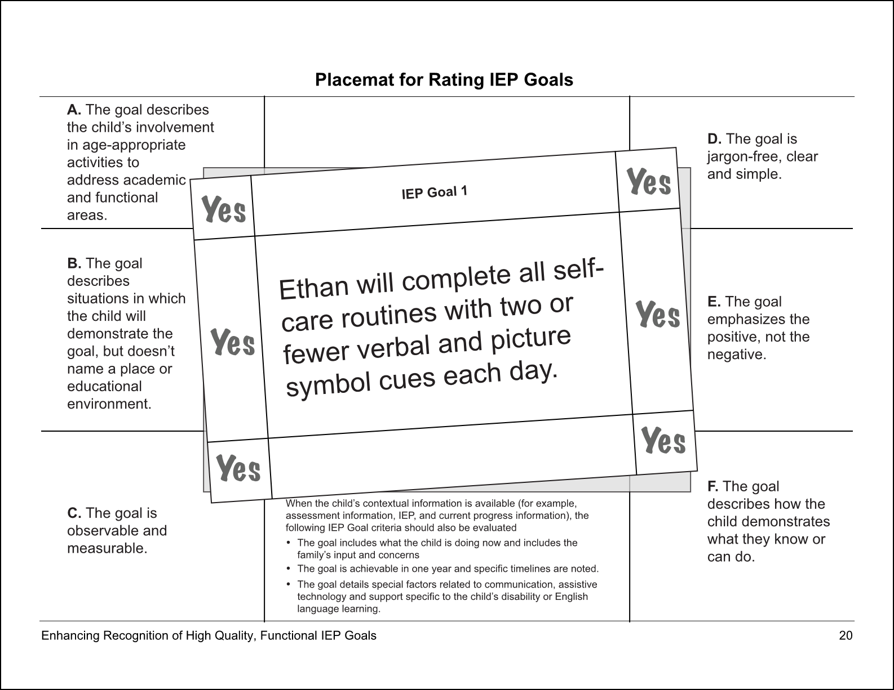
Optional 11x17” Placemat: http://ectacenter.org/~pdfs/pubs/rating-iep-placemat-11x17.pdf

Debriefing the Activity with Participants
After completing the activity, prompt participants with questions, for example:
- Where did you get stuck with a goal?
- What sorts of varying interpretations of the criteria did you find?
- How might this activity help you in your work and within your team?
- What additional supports do you need to help you successfully identify if an IEP Goal is of high quality and is participation-based?
Those using the activity to fit the context of the participants and their learning needs might add other questions to the debriefing.

Rating IEP Goals Using Worksheets
This version of the activity is ideal for groups where each participant rates the outcomes on their own.
- Provide copies of the Criteria (page 6) and the Worksheet (pages 24–26) to participants.
- Have participants rate each outcome using the criteria, recording a “Yes” or a “No”. Remind the participants that additional criteria should be considered when a child’s IEP and assessment information is available.
- Have the groups discuss and determine if the statement is high quality (meets all criteria) or substandard (did not meet all criteria).
- Participants can then compare their answers with the Answer Key (pages 21–23).

Rating IEP Goals Using Minimal Materials
This simple and environmentally friendly version of the is ideal for small groups. To reduce the amount of notetaking needed, review the Answer Key (pages 20–21) after each outcome.
- Print a copy of the Criteria and Sample IEP Goals (pages 6–7) for each participant.
- Have the group discuss and rate each statement according to the criteria, determining if it is high quality (meets all criteria) or substandard (did not meet all criteria). Remind the participants that additional criteria should be considered when a child’s IEP and assessment information is available.

Criteria Defining High Quality, Participation-Based IEP Goals

A. The goal describes the child’s involvement in age-appropriate activities to address academic and functional areas.
The goal address developmentally appropriate routines and activities related to promoting the child’s positive social relationships, acquisition and use of knowledge and skills, and use of appropriate actions to meet needs, including early literacy and math, as well as activities and skills needed for functional independence.
Isolated skills (test items that were missed during evaluation) or rote responses (memorizing days of the week or colors), are not considered age-appropriate, academic or functional for young children.

B. The goal describes situations in which the child will demonstrate the goal, but doesn’t name a place or educational environment.
The goals is something the child can accomplish anywhere.
Example: “Sally will be supported to stand while painting or drawing” meets this criterion, but “Sally will be supported to stand while at the art table,” does not.
Example: “Julia will hang up her coat when coming in from outdoors,” meets this criterion, but “Julia will hang up her coat in her locker when coming in from recess,” does not.

C. The goal is observable and measurable.
The outcome encourages the child’s active participation or engagement. Active words include eat, play, talk, walk, and so on. These words indicate what the child will do.
Passive words reflect a state of being, for example, tolerate and receive. Passive words also reflect a change or lack of change in performance (for example, increase, decrease, improve, and maintain).
Measurable means evidence is documentable, quantifiable, and describes the level of performance needed to achieve the goal or determine progress. Measurements include how often (“4 of 5 times” or “every time”), and how long (“for five minutes”). Measurements are developmentally and individually appropriate.

D. The goal jargon-free, clear, and simple.
The goal is understandable by the family, uses plain language, does not include professional jargon or “practitioner-speak.”
Example: The outcome describes how the child will move, such as reaching up or down for toys, not “range of motion”.
Example: The outcome describes a child speaking words clearly or making themselves understood, not their “articulation”.

E. The goal emphasizes the positive, not the negative.
The outcome statement is phrased in the positive. It states what child or family will do, as opposed to what they will not do or what they will stop doing.
If there are any negative words within the statement, it is not a positively worded outcome.
Example: “Johnny will not spit out food when eating with his family” does not meet this criterion, but “Johnny will chew and swallow food when eating with his family” does.

F. The goal describes how the child demonstrates what they know or can do.
The goal includes clear strategies or accommodations.
Example: “Alice will answer questions,” does not meet this criterion, but “Using cards or pictures, Alice will play games with an adult and child to both ask and answer questions,” does.

Sample IEP Goal Statements

- Ethan will complete all self-care routines with two or fewer verbal and picture symbol cues each day.
- Daniel will make three choices 4 out of 5 days.
- Ethan will improve his visual and auditory attention to routine tasks.
- Clarita will be safe when climbing up and down stairs and moving around obstacles by holding an adults hand every time during daily routines.
- Jay will play by himself for at least 15 minutes at Cherry Cheeks Preschool, choosing various types of toys (blocks, art materials, trucks).
- Efrat will use large crayons or thick markers by himself to draw pictures that tell a story.
- On her own, Jayne will play with a variety of toys and materials (pretending to cook, playing with toys, using paints or crayons) at least twice a day.
- At least twice a week, Betsy will share details with adults and friends about recent activities using three to four complete sentences.
- When given two items or tasks, Nathan will choose by reaching for the object or picture he wants 3 out of 4 times during play and mealtime each day.
- With a verbal reminder to do so, Juan will put on his jacket by himself each day before going outside.
- Denny will use words to say what he needs and wants without reminders in a variety of daily routines and experiences at school.
- Pevita will stop crying when separating from parents after arriving at child care each day.
- Abby will use pincer grasp whenever playing with small toys and eating.
- Gelada will play games with other children.
- Chris will play in all play areas at Sunshine Child Care each day.
- I want my child to talk more so that he is better understood by others.
- Henry will immediately come when told to do so.
- Gerardo will talk better and do things he likes throughout his day, similar to other 3-year-olds.
- When asked what she wants, Annie will use words or gestures, including refusals to convey wants and need 4 out of 5 times throughout daily routines and activities.
- Dianna will clear her plate from the table at the end of each meal or snack without reminders.
- Whenever verbally prompted, Melissa will give a two-word response to a question without crying or displaying physical resistance during transition from one activity to another.
- When sitting in a chair with arms or other supports (pads and a footrest), Ellie will feed herself using a spoon or fork for at least half her meal each day.
- Mattie will play by selecting a toy, trying new ways to play with it, or exploring other toys for 5 minutes at a time at least once each day.
- Kenny will respond to simple questions (“Do you want more?” or “What’s this?”) with appropriate words or actions 4 out of 5 times when looking at books each day.
When the child’s contextual information is available (for example, assessment information, IEP, and current progress information), the following IEP Goal criteria should also be evaluated:
- The goal includes what the child is doing now and includes the family’s input and concerns.
- The goal is achievable in one year and specific timelines are noted.
- The goal details special factors related to communication, assistive technology and support specific to the child’s disability or English language learning.

IEP Goal 1

Ethan will complete all self-care routines with two or fewer verbal and picture symbol cues each day.

IEP Goal 2

Daniel will make three choices 4 out of 5 days.

IEP Goal 3

Ethan will improve his visual and auditory attention to routine tasks.

IEP Goal 4
Clarita will be safe when climbing up and down stairs and moving around obstacles by holding an adults hand every time during daily routines.

IEP Goal 5
Jay will play by himself for at least 15 minutes at Cherry Cheeks Preschool, choosing various types of toys (blocks, art materials, trucks).

IEP Goal 6

Efrat will use large crayons or thick markers by himself to draw pictures that tell a story.

IEP Goal 7
On her own, Jayne will play with a variety of toys and materials (pretending to cook, playing with toys, using paints or crayons) at least twice a day.

IEP Goal 8
At least twice a week, Betsy will share details with adults and friends about recent activities using three to four complete sentences.

IEP Goal 9
When given two items or tasks, Nathan will choose by reaching for the object or picture he wants 3 out of 4 times during play and mealtime each day.

IEP Goal 10

With a verbal reminder to do so, Juan will put on his jacket by himself each day before going outside.

IEP Goal 11
Denny will use words to say what he needs and wants without reminders in a variety of daily routines and experiences at school.

IEP Goal 12

Pevita will stop crying when separating from parents after arriving at child care each day.

IEP Goal 13

Abby will use pincer grasp whenever playing with small toys and eating.

IEP Goal 14

Gelada will play games with other children.

IEP Goal 15

Chris will play in all play areas at Sunshine Child Care each day.

IEP Goal 16

I want my child to talk more so that he is better understood by others.

IEP Goal 17

Henry will immediately come when told to do so.

IEP Goal 18

Gerardo will talk better and do things he likes throughout his day, similar to other 3-year-olds.

IEP Goal 19
When asked what she wants, Annie will use words or gestures, including refusals to convey wants and needs 4 out of 5 times throughout daily routines and activities.

IEP Goal 20

Dianna will clear her plate from the table at the end of each meal or snack without reminders.

IEP Goal 21
When verbally prompted, Melissa will give a two-word response to a question without crying or displaying physical resistance during transition from one activity to another.

IEP Goal 22
When sitting in a chair with arms or other supports (pads and a footrest), Ellie will feed herself using a spoon or fork for at least half her meal each day.

IEP Goal 23
Mattie will play by selecting a toy, trying new ways to play with it, or exploring other toys for 5 minutes at a time at least once each day.

IEP Goal 24
Kenny will respond to simple questions (“Do you want more?” or “What’s this?”) with appropriate words or actions 4 out of 5 times when looking at books each day.

Placemat for Rating IEP Goal Statements
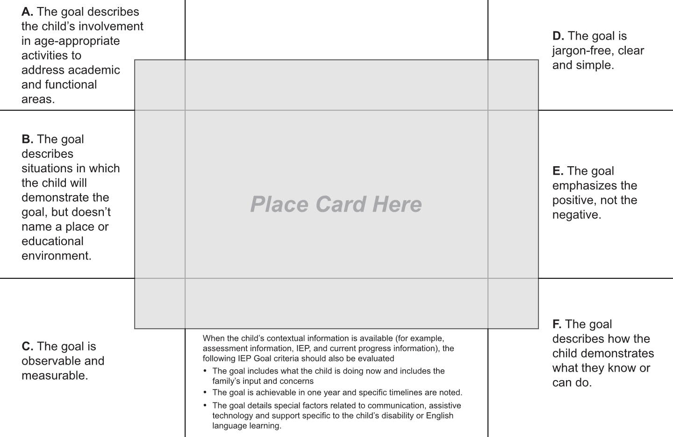

Answer Key for Rating IEP Goal
A high quality goal meets all criteria. A substandard statement does not meet all criteria.
Sample IEP Goal | A.  Age-appropriate activities | B.  Describes situations, not environments | C.  Observable and measurable | D.  Jargon-free, clear, simple | E.  Positive, not negative | F.  Describes how the child demonstrates
- Ethan will complete all self-care routines with two or fewer verbal and picture symbol cues each day. | Yes | No | No | No | Yes | No
- Daniel will make 3 choices four out of five days. | No | No | No | Yes | Yes | No
- Ethan will improve his visual and auditory attention to routine tasks. | Yes | No | No | No | Yes | No
- Clarita will be safe when climbing up and down stairs and moving around obstacles by holding an adults hand every time during daily routines. | Yes | Yes | Yes | Yes | Yes | Yes
- Jay will play by himself for at least 15 minutes at Cherry Cheeks Preschool, choosing various types of toys (blocks, art materials, trucks). | Yes | No | Yes | Yes | Yes | Yes
- Efrat will use large crayons or thick markers by himself to draw pictures that tell a story. | Yes | Yes | Yes | Yes | Yes | Yes
- On her own, Jayne will play with a variety of toys and materials (pretending to cook, playing with toys, using paints or crayons) at least twice a day. | Yes | Yes | Yes | Yes | Yes | Yes
- At least twice a week, Betsy will share details with adults and friends about recent activities using three to four complete sentences. | Yes | Yes | Yes | Yes | Yes | Yes
- When given two items or tasks, Nathan will choose by reaching for the object or picture he wants 3 out of 4 times during play and mealtime each day. | Yes | Yes | Yes | Yes | Yes | Yes
- With a verbal reminder to do so, Juan will put on his jacket by himself each day before going outside. | Yes | Yes | Yes | Yes | Yes | Yes
- Denny will use words to say what he needs and wants without reminders in a variety of daily routines and experiences at school. | No | No | Yes | Yes | Yes | Yes
- Pevita will stop crying when separating from parents after arriving at child care each day. | Yes | No | Yes | Yes | No | No
- Abby will use pincer grasp whenever playing with small toys and eating. | Yes | Yes | Yes | No | Yes | Yes
- Gelada will play games with other children. | Yes | No | No | Yes | Yes | No
- Chris will play in all play areas at Sunshine Child Care each day. | Yes | No | No | Yes | Yes | Yes
- I want my child to talk more so that he is better understood by others. | Yes | No | No | Yes | Yes | No
- Henry will immediately come when told to do so. | No | No | No | Yes | Yes | No
- Gerardo will talk better and do things he likes throughout his day, similar to other 3-year-olds. | Yes | No | Yes | Yes | Yes | No
- When asked what she wants, Annie will use words or gestures, including refusals to convey wants and needs 4 out of 5 times throughout daily routines and activities. | Yes | Yes | Yes | Yes | Yes | Yes
- Dianna will clear her plate from the table at the end of each meal or snack without reminders. | Yes | Yes | Yes | Yes | Yes | Yes
- When verbally prompted, Melissa will give a two-word response to a question without crying or displaying physical resistance during transition from one activity to another. | Yes | Yes | Yes | No | No | Yes
- When sitting in a chair with arms or other supports (pads and a footrest), Ellie will feed herself using a spoon or fork for at least half her meal each day. | Yes | Yes | Yes | Yes | Yes | Yes
- Mattie will play by selecting a toy, trying new ways to play with it, or exploring other toys for 5 minutes at a time at least once each day. | Yes | Yes | Yes | Yes | Yes | Yes
- Kenny will respond to simple questions (“Do you want more?” or “What’s this?”) with appropriate words or actions 4 out of 5 times when looking at books each day. | Yes | Yes | Yes | Yes | Yes | Yes

Worksheet for Rating IEP Goal Statements
Rate each goal using the criteria to determine if it is high quality (meets all criteria) or substandard (did not meet all criteria).

Sample IEP Goal | A.  Age-appropriate activities | B.  Describes situations, not environments | C.  Observable and measurable | D.  Jargon-free, clear, simple | E.  Positive, not negative | F.  Describes how the child demonstrates
- Ethan will complete all self-care routines with two or fewer verbal and picture symbol cues each day.
- Daniel will make 3 choices four out of five days.
- Ethan will improve his visual and auditory attention to routine tasks.
- Clarita will be safe when climbing up and down stairs and moving around obstacles by holding an adults hand every time during daily routines.
- Jay will play by himself for at least 15 minutes at Cherry Cheeks Preschool, choosing various types of toys (blocks, art materials, trucks).
- Efrat will use large crayons or thick markers by himself to draw pictures that tell a story.
- On her own, Jayne will play with a variety of toys and materials (pretending to cook, playing with toys, using paints or crayons) at least twice a day.
- At least twice a week, Betsy will share details with adults and friends about recent activities using three to four complete sentences.
- When given two items or tasks, Nathan will choose by reaching for the object or picture he wants 3 out of 4 times during play and mealtime each day.
- With a verbal reminder to do so, Juan will put on his jacket by himself each day before going outside.
- Denny will use words to say what he needs and wants without reminders in a variety of daily routines and experiences at school.
- Pevita will stop crying when separating from parents after arriving at child care each day.
- Abby will use pincer grasp whenever playing with small toys and eating.
- Gelada will play games with other children.
- Chris will play in all play areas at Sunshine Child Care each day.
- I want my child to talk more so that he is better understood by others.
- Henry will immediately come when told to do so.
- Gerardo will talk better and do things he likes throughout his day, similar to other 3-year-olds.
- When asked what she wants, Annie will use words or gestures, including refusals to convey wants and needs 4 out of 5 times throughout daily routines and activities.
- Dianna will clear her plate from the table at the end of each meal or snack without reminders.
- When verbally prompted, Melissa will give a two-word response to a question without crying or displaying physical resistance during transition from one activity to another.
- When sitting in a chair with arms or other supports (pads and a footrest), Ellie will feed herself using a spoon or fork for at least half her meal each day.
- Mattie will play by selecting a toy, trying new ways to play with it, or exploring other toys for 5 minutes at a time at least once each day.
- Kenny will respond to simple questions (“Do you want more?” or “What’s this?”) with appropriate words or actions 4 out of 5 times when looking at books each day.

References

- McWilliam, R. A. (2013). Routines-Based Early Intervention. Retrieved from https://ectacenter.org/~pdfs/meetings/data2013/9-McWilliam_handout.pdf
- McWilliam, R. A. (2009). Goal Functionality Scale III. Retrieved from https://ectacenter.org/~pdfs/topics/families/GoalFunctionalityScaleIII_2_.pdf
- Rush, M. L., & Shelden, D. D. (2009). Tips and techniques for developing participation-based IFSP outcomes statements, BriefCASE, 2(1). Retrieved from https://fipp.ncdhhs.gov/wp-content/uploads/briefcase_vol2_no1.pdf
- U.S. Department of Education, Office of Special Education and Rehabilitative Services. (2000). A guide to the Individualized Education Program. Retrieved from https://www2.ed.gov/parents/needs/speced/iepguide/iepguide.pdf
- U.S. Department of Education, Office of Special Education and Rehabilitative Services. (n.d.). Model form: Individualized Education Plan. Retrieved from https://www2.ed.gov/policy/speced/guid/idea/modelform-iep.pdf
- Bar-Lev, N., Van Haren, B., Laffin, K., Wright, A., Derginer, M., Graves, T., Kubinski, E., & Bernt,. S. (2009). A guide to connecting academic standards and IEPs.
- OSEP TA Community of Practice, Workgroup on Principles and Practices in Natural Environments. (2008). Mission and key principles of early intervention services. Retrieved from https://www.ectacenter.org/~pdfs/topics/families/Finalmissionandprinciples3_11_08.pdf
- OSEP TA Community of Practice, Workgroup on Principles and Practices in Natural Environments. (2008). Seven key principles: Looks like/doesn't look like. Retrieved from https://ectacenter.org/~pdfs/topics/families/Principles_LooksLike_DoesntLookLike3_11_08.pdf
- OSEP TA Community of Practice, Workgroup on Principles and Practices in Natural Environments. (2008). Agreed upon practices for providing early intervention services in natural environments. Retrieved from https://ectacenter.org/~pdfs/topics/families/AgreedUponPractices_FinalDraft2_01_08.pdf
- Early Childhood Technical Assistance Center. (2024). IFSP/IEP-Outcomes Integration. Retrieved from https://ectacenter.org/eco/pages/ifsp-iep.asp
- Early Childhood Outcomes Center, IFSP/IEP-Outcomes Integration Think Tank. (2010). Integrating child outcome measurement with the Individualized Education Program (IEP) process: Implementation Rating Scale.

