State Child Outcomes Data Quality Profile
Terra Part B 619

Comparison of State and National Data

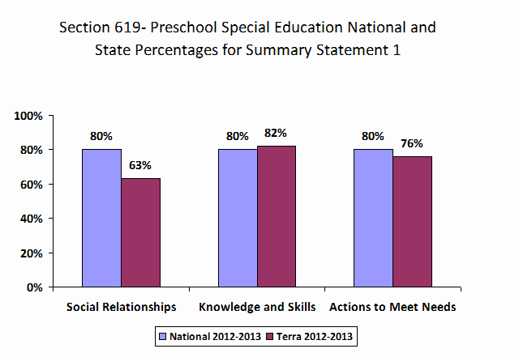
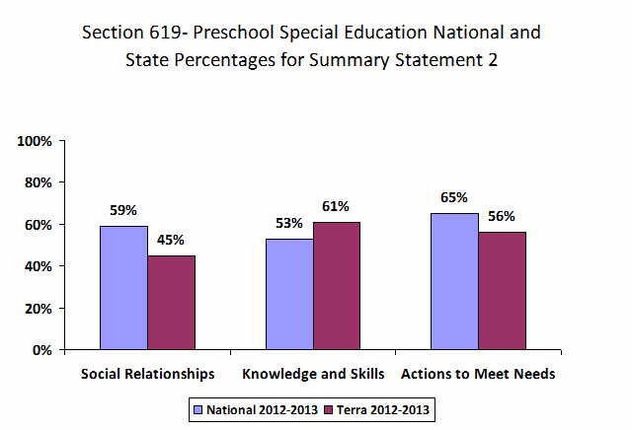

Data Quality

There are several main criteria for identifying states with quality data for inclusion in the national analysis. The first is that the data are complete and that the state reports data on enough children. The second is that the patterns of the progress categories reported by a state are within reasonably expected patterns and ranges.

Completeness of Data Trends over Time

For Part B 619, at minimum, it is expected that states report data on 12% or more of child count using the following equation:

Number of children reported for the outcome / Child count

It is important to note that the estimates provided are based upon publicly available information, but some states have established more accurate methods for estimating the number of children receiving services.

The graphs below plot the state’s data over time in relation to the national average and one standard deviation (SD) above and below the national average.

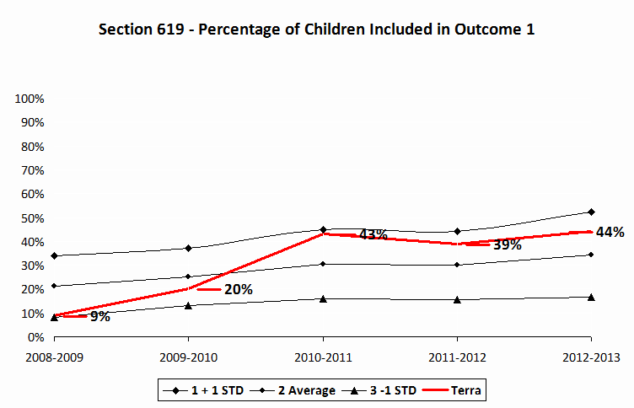
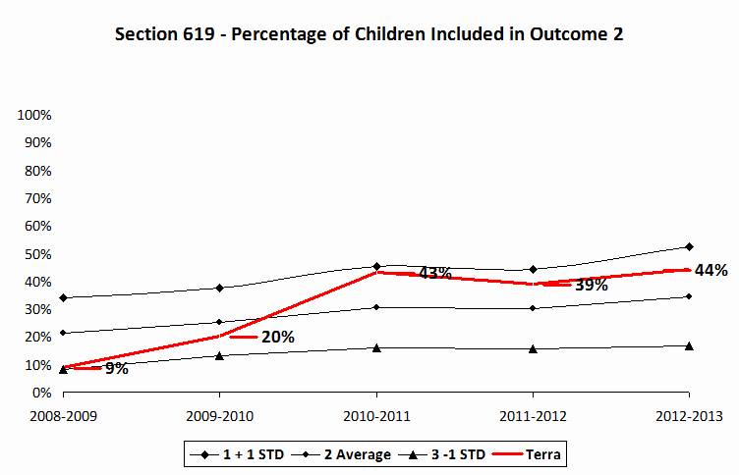
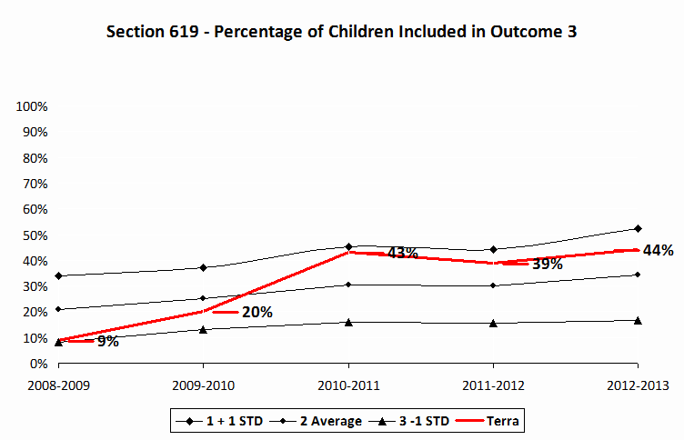

Expected Patterns for Progress Categories

The expected patterns and ranges for the progress categories are listed below. As a minimum quality criteria currently used for the national analysis, the values for progress category ‘a,’ did not improve functioning, are expected to be no greater than 10%. However, we recommend that states use no greater than 5% as an indicator of data quality. The values for progress category ‘e,’ maintained functioning at a level comparable to same-aged peers, are expected to be greater than 5% and less than 65%.

Category a | Category e
0 | <5%
>10% | >65%

State | Outcome | Category A | Category E
TR | Outcome 1 | 0 | 0
TR | Outcome 2 | 0 | 0
TR | Outcome 3 | 0 | 0

1 = out of range for expected pattern; 0 = within expected pattern

For states or territories that serve a small number of children, these data should be interpreted cautiously as they may be more likely to show unexpected patterns because a single child may represent a larger proportion of the children served.

Child Outcomes State Trends over Time

The table below summarizes the main types of change that may be observed over time and possible interpretations.

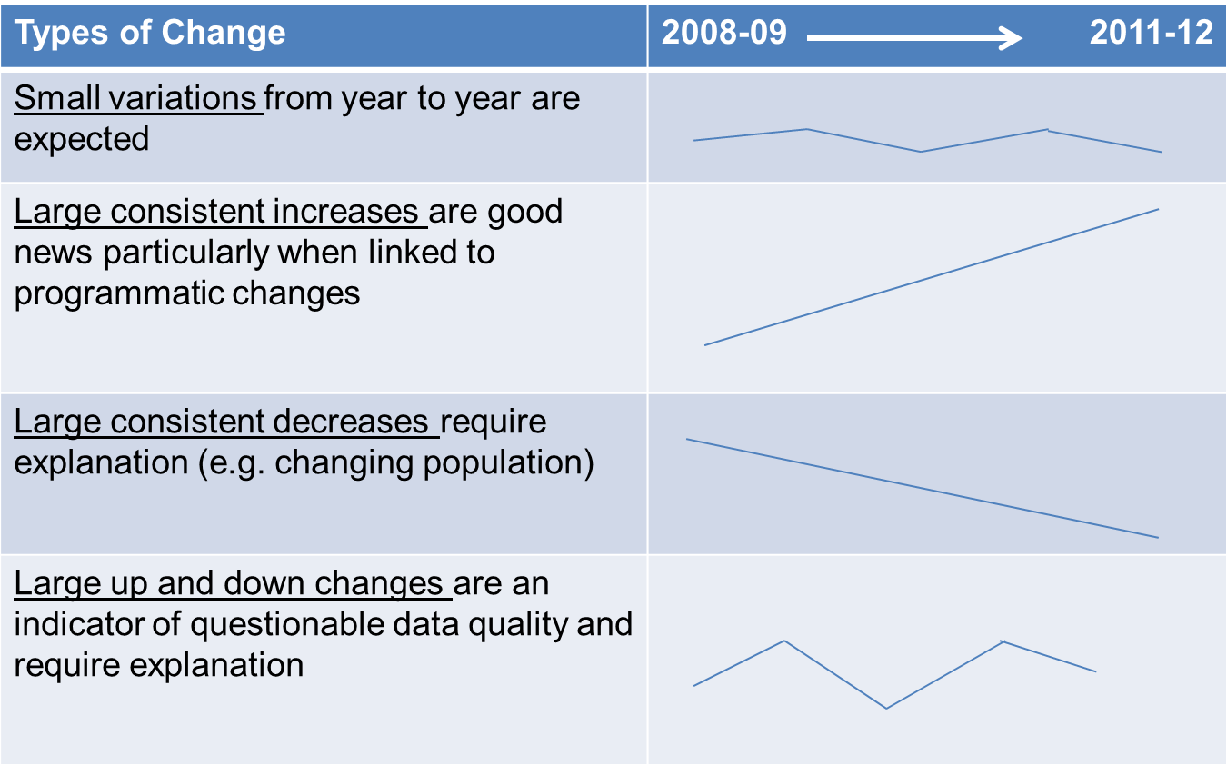

The graphs below plot the state’s data over time in relation to the national average and one standard deviation (SD) above and below the national average.
