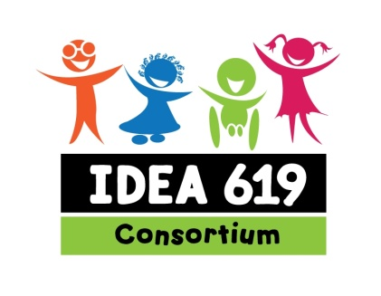
Early Childhood Special Education
Consortium of State 619 Coordinators
=======================================================
Annual 619 Consortium Meeting

619
Leadership Team

Verna Thompson
Chair
Delaware

Meredith Cathcart
Past Chair
California

Barb Tkach
Vice Chair
New Jersey

Nancy Skorheim
Secretary
North Dakota

Region 1 Northeast
Cindy Brown
Maine

Kate Rogers
Vermont

Region 2 Mid-South
Phyllis Mondak
Virginia

Region 3 Southeast
Jan Stevenson
Georgia

Region 4 North Central
Pam Reising-Rechner
Illinois

Region 5 Mountain Plains
Penny Dell
Colorado

Region 6 Western
Sherry Halley
619 Nevada

New Orleans
September 7, 2014
8:00 – 4:30
Facilitators ~ Verna Thompson and Barbara Tkach
8:00 Networking

8:30 Meet and Greet
- Ice Breaker ~ Sherry

9:00 619 Consortium Organization
- Introductions ~ Verna
Leadership Team and Regional Representatives
New 619 Coordinators by regions
- 619 Consortium Election Results ~ Barbara
New Leadership Team and Regional Representatives
- Organizational Guidelines Presented ~ Barbara
- 619 Accomplishments ~ Verna
- Outcome/focus area with action steps ~ Jan
Small Group Discussion

9:15 OSEP Topics ~ Anne Karasek and Priscilla Irvine
- SSIP Update – What is OSEP’s vision for 619?
- IDEA Reauthorization
Funding Levels (auto spending cuts)
RRC Status Update
Organizational Updates:
- NASDSE ~ Nancy Reder
- ECTA, IDC, DaSy ~ Debbie Cate, Martha Diefendorf

10:30 Break

10:45 Small Group Discussions ~ Verna and Debbie
- SSIP Table Topics with Discussion Guide
Focus on Outcome 1 – Social Emotional skills
Focus on Outcome 2 – Early Literacy/Reading
Partnering with Part C
Partnering with Part B K-12
Partnering with RTTT ELC and other EC Initiatives
Other Topics
Preschool Development Grants
Inclusion and 619
- Topic sharing by table at 11:45

12:00 619 Meeting with ITCA
- Part C/619 Table Discussions
- Congressional Updates ~ Sharon Walsh

2:00 Developing Statewide Quality 619 Practices ~~ Robin McWilliam

4:00 OSEP Updates ~ Ruth Ryder

4:15 Early Childhood Updates ~ Jana Martella

4:30 Evaluation and Adjourn Meeting ~ Verna and Barbara

