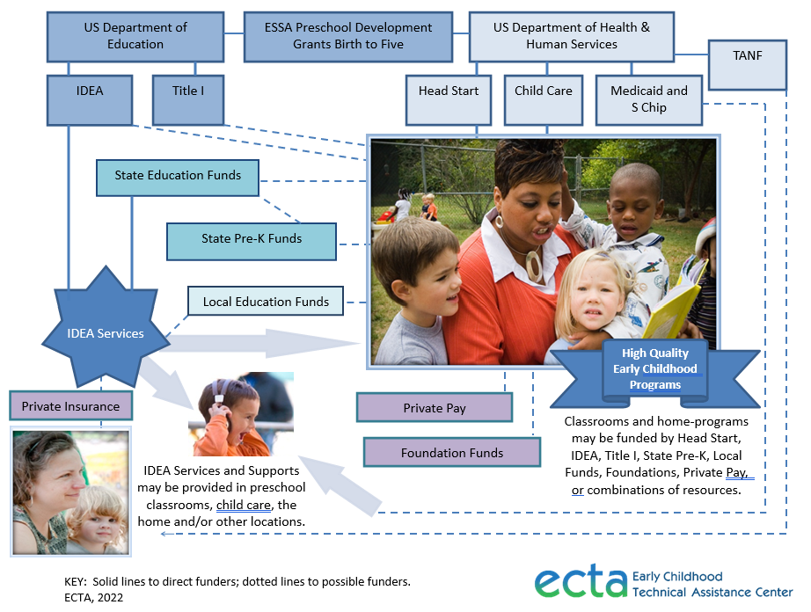

The following table summarizes major Federal and State early care and education funding streams that may be used to support young children with disabilities.

Programs
 | Federal Education Funds
IDEA: Preschool Grants for Children with Disabilities | The Preschool Grants Program is authorized under Section 619 of Part B of IDEA and administered by the Office of Special Education Programs, ED. It was established to provide grants to States to serve young children with disabilities, ages 3 through 5 years. http://www2.ed.gov/about/offices/list/osers/osep/index.html
Title I Preschool | Many school districts support preschool programs with their Title I (Education for the Disadvantaged) funds. More than 50,000 public schools across the country use Title I funds to provide additional academic support and learning opportunities to help low-achieving children master challenging curricula and meet State standards in core academic subjects. http://www2.ed.gov/programs/titleiparta/index.html
ESSA Preschool Development Grants Birth through Five  (PDG B-5) | PDG B-5 grants, which differ significantly from the previous Preschool Development Grants, are designed to fund states to conduct a comprehensive statewide birth through five needs assessment followed by in-depth strategic planning, while enhancing parent choice and expanding the current mixed delivery system consisting of a wide range of provider types and settings, including child care centers and home-based child care providers, Head Start and Early Head Start, state pre-kindergarten, and home visiting service providers across the public, private and faith-based sectors. https://www.acf.hhs.gov/ecd/early-learning/preschool-development-grants
 | Federal Health and Human Services Funds
Head Start/Early Head Start | Head Start and Early Head Start programs are free, federally funded programs designed to promote school readiness for children from low-income families. Early Head Start serves pregnant women and families with children under age 3. Head Start programs serve children between 3 and 5 years old. These programs encourage parent involvement through regular visits to the child’s home, regular opportunities for parents to volunteer in the program, and special activities. Head Start and Early Head Start programs also link children and families to other services in the community. https://www.acf.hhs.gov/ohs
Child Care Development Funds  (CCDF) | CCDF assists low-income families, families receiving temporary public assistance, and those transitioning from public assistance in obtaining child care so they can work or attend training/education. CCD is administered by the Office of Child Care, DHHS, and provides grants to States, Territories and Tribes to serve children younger than 13 years; however, some grantees may elect to serve children ages 13 to 19 who are physically or mentally incapacitated or under court supervision. https://www.acf.hhs.gov/occ/initiatives
Medicaid | Medicaid is a public health insurance which pays for services for children, including preventive care, immunizations, screening and treatment of health conditions, doctor and hospital visits, and vision and dental care for families who are income eligible and/or children with disabilities. https://www.medicaid.gov/
Temporary Assistance for Needy Families (TANF) | TANF is administered by the Office of Family Assistance, DHSS, and provides grants to States, Territories, or Tribes to assist needy families with children so that children can be cared for in their own homes; reduce dependency by promoting job preparation, work, and marriage; reduce and prevent out-of-wedlock pregnancies; and to encourage the formation and maintenance of two-parent families. States may transfer TANF funds to CCDF or directly spend funds on child care. https://www.acf.hhs.gov/ofa/programs/tanf
 | State and Local
State/Local Education Funds | State and local dollars are primary funding sources of public K-12 education (see individual state departments of education websites).
State-Funded Prekindergarten | An early learning program invests public resources, e.g., State general revenue funds. In preschool education to increase access and improve quality. The Funding often goes to local school districts for programming that emphasizes school readiness. https://nieer.org/
 | Private
Private Insurance | Private family or child insurance used with family permission.
Private Pay | Funding sources such as parental payment or co-pay, scholarships, and/or donations, may support programs and/or enrollment of children.
Foundation Funds | May be utilized to support programs and/or enrollment of individuals.

COVID Relief Funds Supporting IDEA Services and Early Childhood Programs – At-a-Glance
The Coronavirus Aid, Relief, and Economic Security Act (CARES) was enacted on March 27, 2020 to provide emergency assistance and health care response for individuals, families, and businesses affected by the COVID-19 pandemic. Additional funds from the Coronavirus Response and Relief Supplemental Appropriations Act (CRRSA) were signed into law December 27, 2020. On March 11, 2021, American Recue Plan Act (ARP) was signed into law. The following table provides a short description and links to information about key COVID relief funds that may be used to support IDEA services and opportunities for children with disabilities to have seats in regular early childhood programs. Please note these funds are time limited and varied in their obligation and expenditure requirements.
Funds | Description
 | Federal Education Funds
ARP IDEA | Of the $130 billion that was allocated to the Department of Education, the following amounts were earmarked for IDEA grant awards as supplemental FFY 2021 funds: $2.58 billion for grants to states under Part B of IDEA, $200 million for preschool grants under IDEA, and $250 million for programs for infants and toddlers under Part C of IDEA. All IDEA (Parts B and C) ARP funds must be used consistently with current IDEA statutory and regulatory requirements. https://www2.ed.gov/policy/speced/leg/arp/arp-idea-fact-sheet.pdf
CARES & CRSSA ESSER | The CARES Act provided funds through the Education Stabilization Fund of the Elementary and Secondary School Emergency Relief (ESSER) Fund. The Education Department awarded these grants to SEAs to provide LEAs with emergency relief funds to address the impact that COVID-19 on elementary and secondary schools. ESSER Funds were awarded in the same proportion as each State received funds under Part A of Title I of the ESEA Act of 1965. https://oese.ed.gov/offices/education-stabilization-fund/elementary-secondary-school-emergency-relief-fund/
ARP  ESSER | Elementary and Secondary School Emergency Relief (ESSER) funds can be used to fund programs for children from birth through kindergarten. These programs can be located on school campuses, in community-based settings in a district’s attendance zone, including local Head Start, child care, and preschool programs. States and LEAs may use ARP funds for early childhood programs, including classroom-based instructional programs, salaries and benefits for teachers and other staff, extended-day programs in Head Start or community-based child care programs, professional development for early childhood professionals, support services, such as nutrition, vision, dental, and counseling services, screening and diagnostic assessments, transition programs, parent involvement initiatives and home visiting programs. https://oese.ed.gov/files/2021/05/ESSER.GEER_.FAQs_5.26.21_745AM_FINALb0cd6833f6f46e03ba2d97d30aff953260028045f9ef3b18ea602db4b32b1d99.pdf
 | Federal Health and Human Services Funds
CARES HS | The CARES Act designates additional funds to Head Start to help prepare low-income children for kindergarten, and to support their growth and development by creating a positive environment for them during the public health crisis. Funds were released directly to all 1,600 local Head Start and Early Head Start programs, including tribal programs, in every state and territory. https://www.acf.hhs.gov/media/press/2020/cares-act-gives-extra-750-million-head-start-program
CARES CCDF | CARES Act funds provided through the Child Care Development Fund (CCDF) in each state may be used to provide continued payments to child care providers for decreased enrollment or closures related to coronavirus, and to assure they are able to remain open or reopen. Funds may also be used for child care assistance to emergency responders, health care and other essential workers during response to the coronavirus, regardless of income eligibility requirements. https://www.acf.hhs.gov/occ/policy-guidance/summary-child-care-provisions-coronavirus-aid-relief-and-economic-security-act
ARP HS | ARP included $1 billion for Head Start programs. All Head Start, Early Head Start, and Early Head Start-Child Care Partnership grantees were eligible to receive additional funds proportionally based on funded enrollment levels. Local grantees used funds to reach more families, get facilities ready for in-person comprehensive services, and to support Head Start employees through compensation and professional development initiatives. https://eclkc.ohs.acf.hhs.gov/policy/pi/acf-pi-hs-21-03
ARP CCDF | Provided to Child Care and Development Fund (CCDF) lead agencies in two categories:  1) Supplemental CCDF Discretionary Funding ($15 billion) States may use these funds to support any activities allowable under the Child Care & Development Block Grant Act (CCDBG) and CCDF regulations. https://www.acf.hhs.gov/sites/default/files/documents/occ/CCDF-ACF-IM-2021-03.pdf  2) Stabilization Grants ($24 billion).
 | State and Local
CARES GEER  ESSER | CARES Act funds the Governor’s Emergency Education Relief fund (GEER). Grants based on a formula:60% based on the State’s population of children 5-24, and 40% based on the State’s number of children counted under section 1124(c) of ESEA. Coronavirus Response and Relief Supplemental Appropriations Act, 2021 (CRRSA) provided additional Governor’s Emergency Education Relief (GEER) Funds. https://oese.ed.gov/offices/education-stabilization-fund/governors-emergency-education-relief-fund/
More information is also available on the ECTA page COVID page: https://ectacenter.org/topics/disaster/coronavirus.asp
Related Resources
IDEA
- OSEP ARP landing page: https://www2.ed.gov/policy/speced/leg/arp/index.html
- ARP IDEA Fact sheet: https://www2.ed.gov/policy/speced/leg/arp/arp-idea-fact-sheet.pdf
- Part C Early Intervention Infant Toddler Coordinators Association (ITCA): https://www.ideainfanttoddler.org/index.php
- Quick Reference Guide on Use of Funds: https://cifr.wested.org/resource/quick-reference-guide-on-the-use-of-idea-part-c-funds/
Early Learning within State Education Agencies
- Elementary and Secondary School Emergency Relief Fund Tracker: https://www.ncsl.org/ncsl-in-dc/standing-committees/education/cares-act-elementary-and-secondary-school-emergency-relief-fund-tracker.aspx
- ARP ESSER State Plans: https://oese.ed.gov/offices/american-rescue-plan/american-rescue-plan-elementary-and-secondary-school-emergency-relief/stateplans/
Child Care
- Information Memorandum ARP Act CCDF Discretionary Supplemental Funds: https://www.acf.hhs.gov/sites/default/files/documents/occ/CCDF-ACF-IM-2021-03.pdf
- American Rescue Plan Act of 2021 Supplemental Discretionary Funds: Snapshot of Recommended CCDF Activities for States, Territories, and Tribes: https://childcareta.acf.hhs.gov/sites/default/files/public/arp_supplemental_discretionary_recommended_activities.pdf
- Map of Stabilization Grant Applications: https://childcareta.acf.hhs.gov/state-and-territory-child-care-stabilization-grant-applications
- Increasing Access to Inclusive Environments: https://childcareta.acf.hhs.gov/sites/default/files/public/increasing_access_to_inclusive_environments.pdf
- Using American Rescue Plan Act Funding to Support Systems of Care for Infants/Toddlers and Their Families: https://childcareta.acf.hhs.gov/sites/default/files/public/arp_funding_infant_toddler_focus_508.pdf
- Strategies to Guide the Equitable Allocation of COVID-19 Relief Funding for Early Care and Education: https://buildinitiative.org/wp-content/uploads/2021/12/ABC-brief_ChildTrends_Dec2021.pdf
Head Start
- Guidance on use of ARP funds: https://eclkc.ohs.acf.hhs.gov/policy/pi/acf-pi-hs-21-03
- Examples from the field: https://eclkc.ohs.acf.hhs.gov/about-us/coronavirus/putting-covid-19-funds-work-examples-field
- Benefits for families: https://eclkc.ohs.acf.hhs.gov/browse/keyword/american-rescue-plan
- NHSA ARP Guide: https://www.nhsa.org/wp-content/uploads/2021/03/The-American-Rescue-Plan-Head-Start.pdf

