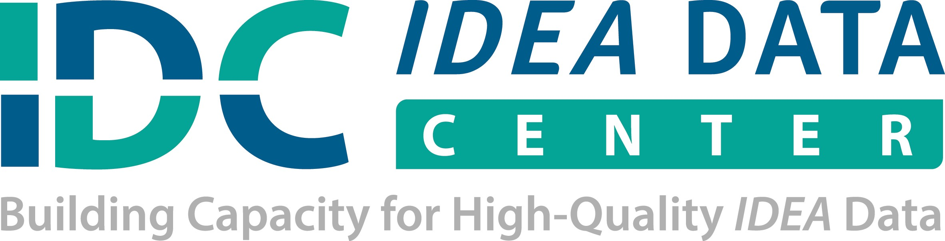

STATE ANALYSIS AND USE PLAN
Purpose

What is our broad objective for conducting this analysis?
Primary Question

What specific question do we want to answer through this analysis?
 | Our Plan | Who Is Responsible? | When Will It Be Completed? | Additional Resources
Data Elements

What data do we need to answer our question?

What data does our Part C program have?

What data can we access within our own agency, or obtain from another agency/entity?

What elements require a new data collection effort?

 | Our Plan | Who Is Responsible? | When Will Work Group Work Be Completed? | Additional Resources
Data Collection Strategies

What tools and sources will we use to gather data?

What existing processes for obtaining, managing, and storing data will we leverage for this analysis?
Data Analysis Strategies

What methods will we use for examining our data?

How will we organize the data to find the relevant patterns, trends, relationships for answering our question?

 | Our Plan | Who Is Responsible? | When Will Work Group Work Be Completed? | Additional Resources
Using Analysis Results

How will we use the results for state and local programming?

What process will we follow to apply the results to our work?
Sharing Analysis Results

Who else needs to see these results?

What formats will best communicate our results and the implications with our stakeholders?

