Operational Decisions | Informing Level | Networking Level | Collaborating Level | Transforming Level
Key actions and behaviors that require your attention | Sharing/Disseminating:  One-way communication | Exchanging:  Two-way communication | Engaging:  Working together on the issue over time | Committing to approach issues through engagement and consensus building
Coalesce the stakeholders around the issue | Convener/lead agency identifies the issue and disseminates information in ways that encourage participation. | A forum is used to bring a core group of stakeholders together with the intent of gathering feedback to inform decisions on the issue. | The core group expands to include a wide array of stakeholders who unite and take joint action on the issue. | There is a unified and unwavering focus on the issue. Trust and respect are evident, even when there are differences of opinion. The group processes align toward a shared goal.
Ensure relevant participation | Convener/lead agency identifies stakeholder  representatives, and informs them of opportunities to participate. | A core group of stakeholders works with the convener to identify/create an infrastructure for meaningful participation and shared learning. | The expanded group of stakeholders recognizes and values the work of others needed to achieve meaningful outcomes. | Broad stakeholder networks share ownership and influence in achieving the outcome.
Translate work into  ways that others participate | Convener/lead agency asks stakeholder representatives to disseminate information on the issue. | A core group of stakeholders uses the infrastructure to exchange information in understandable and mutually respectful ways. | The expanded group of stakeholders involves their networks in bridging knowledge and practice. | Broad stakeholder networks support their constituents throughout the practice change.
Communicate what is changing by actively doing work with the stakeholders | Convener/lead agency asks the stakeholder representatives to convey the benefit in making changes throughout their networks. | A core group of stakeholders use the infrastructure to exchange information about the changes that are occurring. | The expanded group of stakeholders shares the stories of changes achieved because the networks are more engaged in bridging knowledge and practice. | Broad stakeholder networks exchange stories of practice change and outcomes. They communicate the changes in ways the advance acceptance and the changes are enthusiastically embraced.
Demonstrate what is changing by actively doing the work | Stakeholder representatives invite others to participate in discussions on the changes being experienced. | A core group of stakeholders intentionally share stories, exchange information and suggest ideas for action. | The expanded group of stakeholders embraces shared leadership and participates in joint work across the networks. | Within broad stakeholder networks, excellent examples of practice change are routinely observable.

Creating Active Engagement
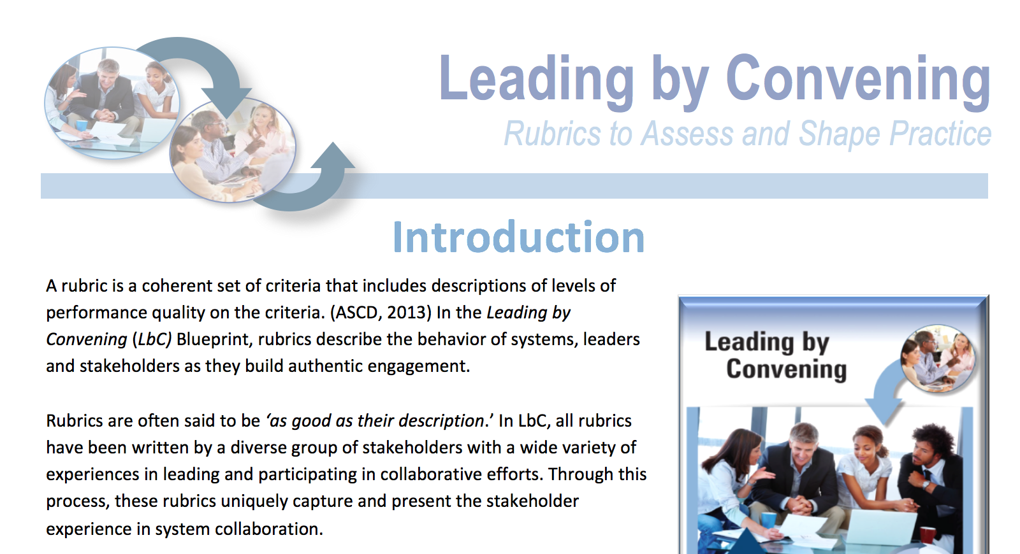
View the Web
Version
Go back to the Introduction

