Planful Changes: Using Self-Assessments to Improve Child and Family Outcome Measurement Systems
Small Group Activities
Activity One
Objective: To get a sense of the relationship between the elements and the quality indicators and the process for documenting evidence and assigning a rating.
- Individually read over the quality indicators that make up your group’s component.
- As a group, select a quality indicator (numbered item) under your component area that you would like to work on. Note: some components only have one quality indicator.
- Assign an element to each individual. Each individual reviews his or her assigned element and thinks about how his/her state is doing on that element. Think about specific examples to share as evidence of where the state is on the element.
- As a group, work through the elements in any order you choose. Each person is to describe how they see their state on their assigned element with others at the table acting as stakeholders. As part of the discussion, consider whether all stakeholders in the state would make the same appraisal and what kinds of dialogue might occur within the state when thinking about this element?
- Based on the discussion, select a rating and record the evidence for each element.
Reflection questions (for discussion in share back):
- What did you think of the process of reviewing each element?
- Did the process make sense? What was difficult?
- Are these elements for which you would want stakeholder involvement? For which you would need multiple perspectives?

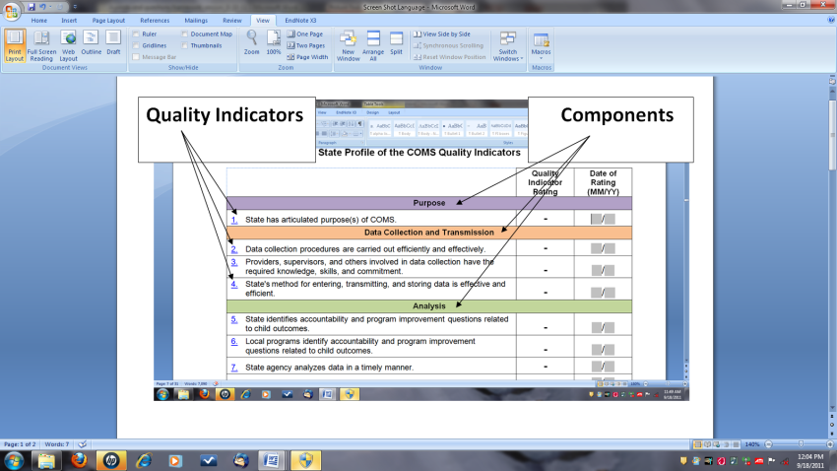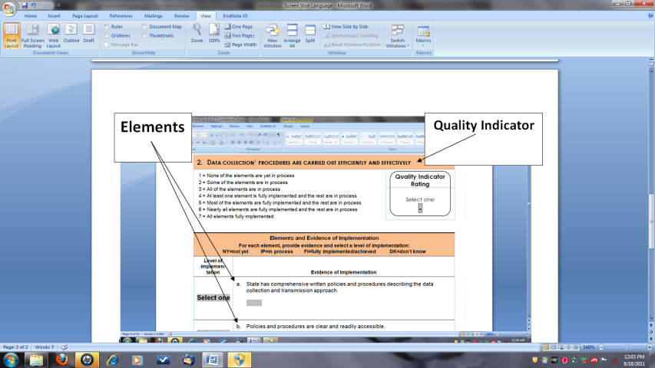

Activity Two
Objective: Participants will take the first steps toward developing a process for how to use the self-assessment tool in their state.
Reflect on and discuss the following questions.
- How do you think the self-assessment might be useful in your state? What is the process that your state might follow to complete the self assessment (e.g., what steps – right after the conference, long-term steps)?
Or, if you have already been using the self-assessment:
What about the way you have been using it has been useful? What might you change or want to do with it as you use it in the future?

- There are two self-assessment tools. One addresses child outcomes and the other focuses on family outcomes and experiences. Describe how you might use each in your state. Consider the order in which you might work with each tool and the possibility of working with them simultaneously versus sequentially, in entirety or focusing on specific components.

- Who might you involve at different steps with the self-assessment?

- Identify resources that would be helpful to benefit the most from the self-assessment process. Examples include additional information from locals, key people with specific kinds of knowledge, technical assistance/facilitation support.

- How would you begin to move from findings on the self-assessment to deciding on specific actions to improve your outcomes measurement system?

